Evaluation of local expressions involves simultaneous renaming and lifting of local definitions.

Let’s try to evaluate this code block:

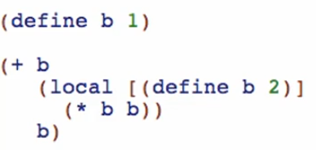

1st evaluation: b

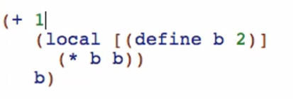

2nd evaluation: local

* 3 things
  + Renaming
  + Lifting
  + Replacing of local expression

1. Renaming
   * Rename definitions and all references to definitions
   * The new name must be GLOBALLY UNIQUE

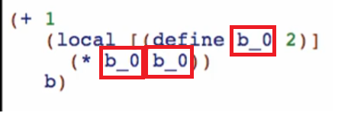

1. Lifting
   * Take the RENAMED definition and lift it out of the local into the GLOBAL/TOP level state
   * Note: all the way to the top-level!

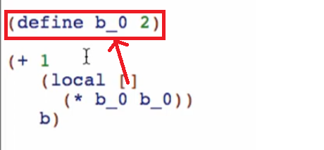

1. Replace
   * Replace the local with its renamed body

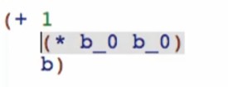

* + We can now evaluate it as a normal expression!

Final local evaluation:

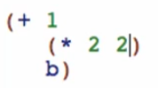 -> 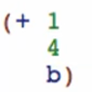

3rd evaluation: last b

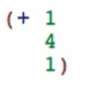

Last: 

Overview:

